

SPE

# Product Development in Cross-discipline Teams - 2 TC2S29 - A19

# Qing Shift Scheduler

# For SME

Group-Qing Bambi

Qing He

Last updated: 2019/10/26

# **PDCT 2 Final Report**

## Project group: Qing-Bambi

### ****The main user requirements for the product:****

### ****Easy to use and save operating time****

### 

* **Functionalities**
* **Shifter:** 
  1. **Edit** a **weekly shift schedule** and **Store** the shift data in the **DB-sft-shift**. The dimensions of **24hours*7days* 8 turns*n projects** records of shift arrangements can be edited **in a single form** by simply **Click-Select.**
  2. **Years round shift can be edited by Select-Years and Week.**
  3. **Any week’s shift arrangement can be Save as another week’s shift.**
  4. **Support projects-select.**
  5. **Auto-Display and Calculate and Convert the Date according to the days.**
  6. **Load and Display the shift of any week for any project to Check and Modify the schedule. Then Save back to the DB.**
  7. **Perform records duplication Check.**

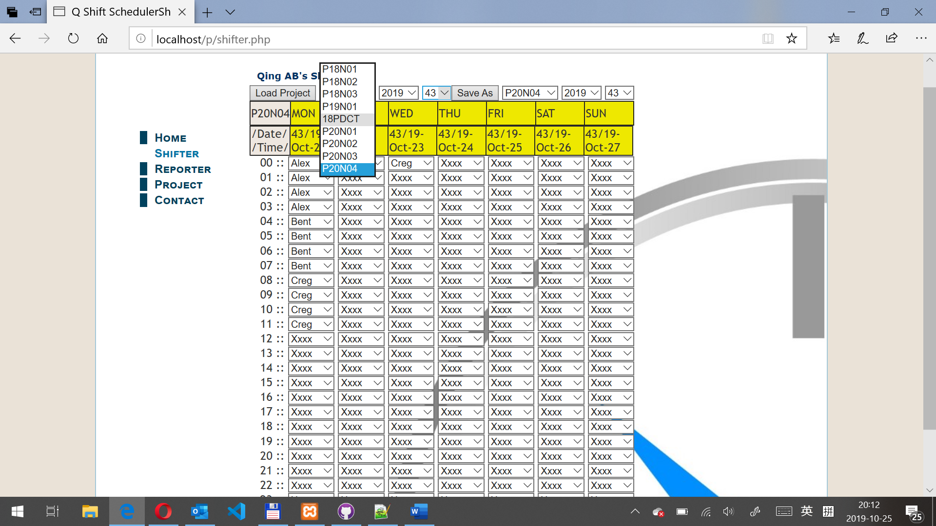

* **Project:** 
  1. **Edit** and **Create** a project with Project Code and **Store** the project information in the **DB “sft” table “project”**. The project code can be displayed and used for the shifter to arrange the shift for the project.
  2. **Project Edit, Save and Store** in the **DB table project.**

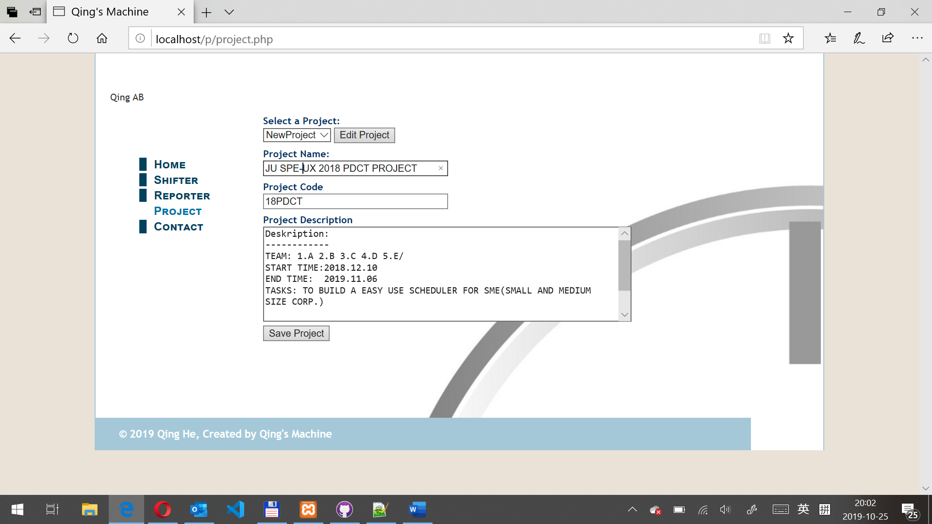

* **Reporter:** 
  1. **Select Project, from/to-Year- Week and Calculate the dates duration, to Generate the Shift Report** of the project with Project Code and Print out as a pdf file.
  2. **Auto-Display and Calculated the Date according to the days.**

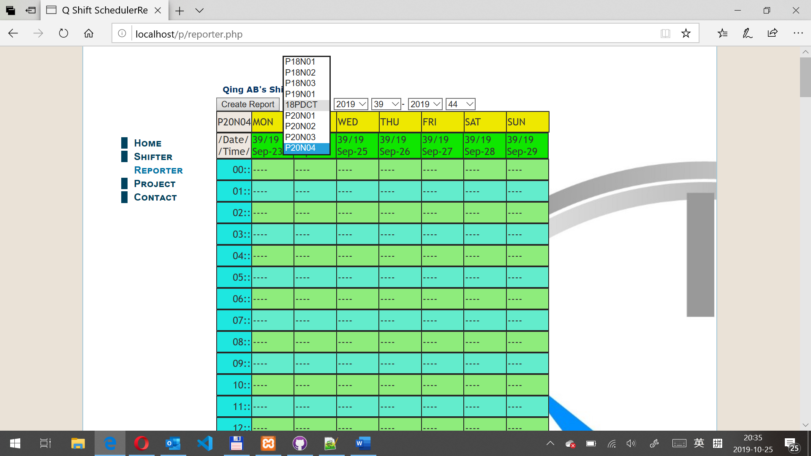

* **SQL DB:** sft

Table 1: shift

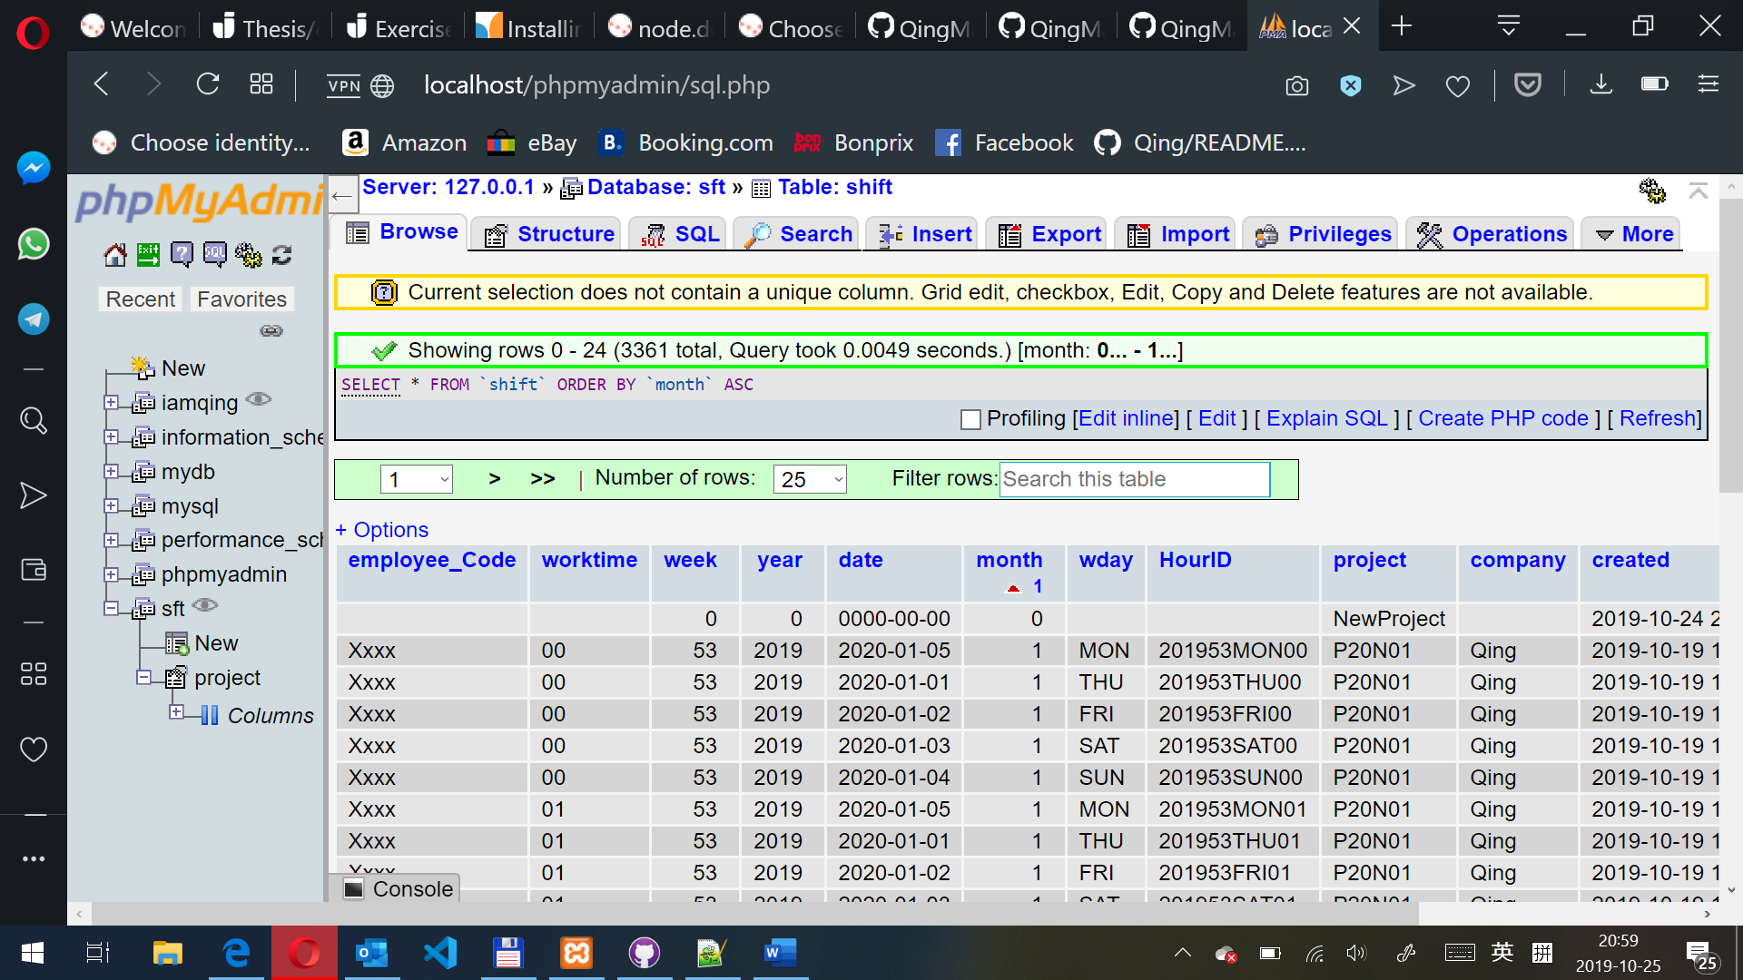

Table 2: project

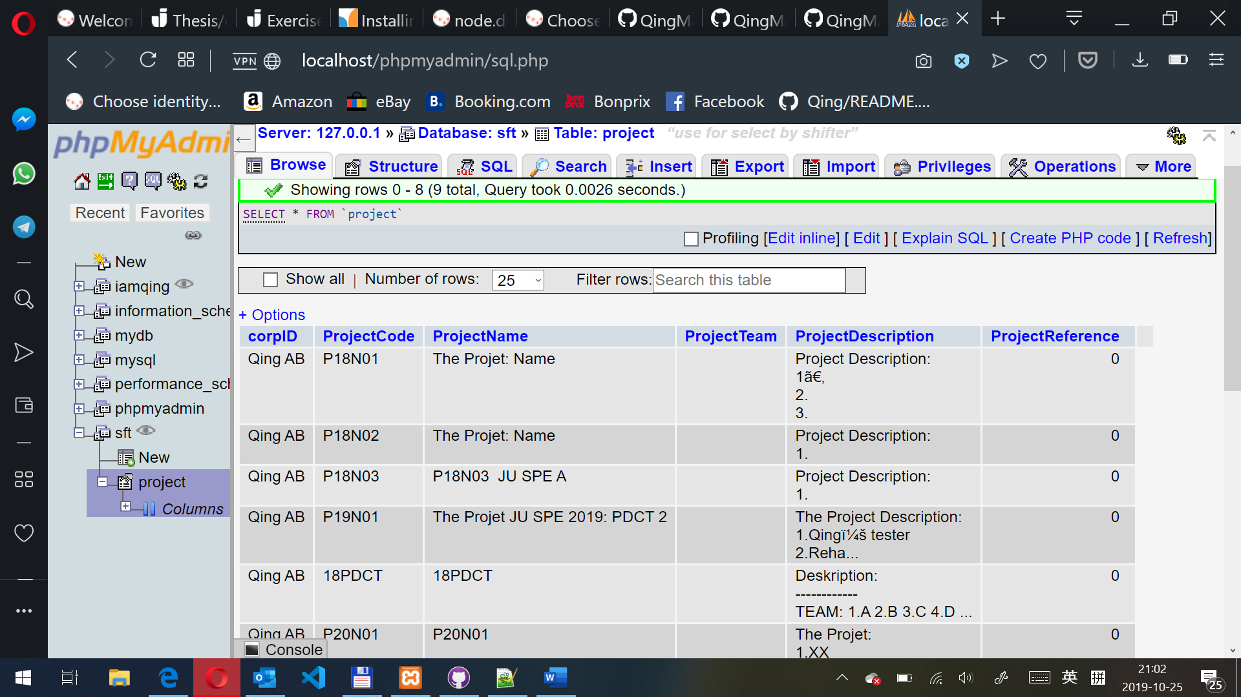

### Documentation:

1. Source Code and Db backup repository:

<https://github.com/QingMachine/Qshift>

<https://github.com/QingMachine/Qshift.git>

1. Tools and languages used:

Git and GitHub, Total Commander, Notepad++, XAMPP, SQL, PHP, HTML, Microsoft EDGE, Opera, Chrome